

**SOEN 6841**

**Software Project Management**

**FALL 2024**

**Group 3**

**Topic 29: Emergency Response Coordination System**

|  |  |
| --- | --- |
| **Group Members** | **Student Id** |
| Harsh Tank | 40269370 |
| Ayush Patel | 40272388 |
| Zeel Divawala | 40272584 |
| Ankush desai | 40271170 |
| Mihir Gediya | 40272399 |

**Professor: Dr. Joumana Dargham**

# PROBLEM IDENTIFICATION

## INTRODUCTION

This project and report focus on addressing a critical gap by seizing the opportunity to develop and commercialize a system that enhances communication and coordination during emergencies. The system will connect first responders, authorities, and the broader community, aiming to serve a diverse range of users not only emergency departments but also residents across Canada.This system will leverage these efforts by offering a modern, scalable solution designed to streamline emergency response across multiple levels of users.

## PROBLEM AND OPPORTUNITY STATEMENT

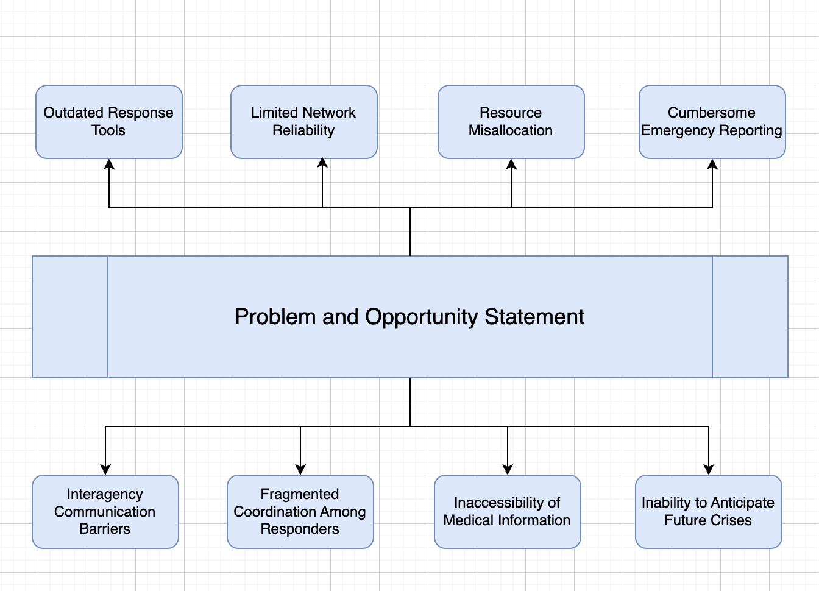

Figure 1.1 Problem and Opportunity Statements

### Cross-Department Compatibility

* **Problems:** Cooperation and information sharing are hampered by the disparate emergency response teams' usage of incompatible communication platforms. During large-scale emergencies, it is challenging for teams from different regions to collaborate seamlessly due to the absence of a uniform platform.
* **Opportunity:** This divide can be closed with a powerful, unified system that combines information from several departments. Instead of starting from scratch, the solution can involve integrating current systems and adding new functionality to them.

### Limitations In Real-Time Information For Responders

* **Problems:** Inadequate or antiquated technology hinders emergency teams' ability to obtain precise real-time information, which slows down decision-making in emergency situations.
* **Opportunity:** Creating a mobile app and real-time dashboard for responders will guarantee that they have access to the most recent data and improve their ability to make decisions quickly.

### Difficulty In Reporting Emergencies

* **Problems**: The public's current means of reporting emergencies are frequently convoluted, which causes delays in response times that can be fatal.
* **Opportunity**: A public-facing, easy-to-use software with a straightforward UI will enable locals to report emergencies promptly and effectively, while also providing more sophisticated functions for individuals who require them.

### Network Dependability And Infrastructure Limitations

* **Problems**: The system's performance is largely dependent on the network infrastructure, which might be unstable in rural or underdeveloped locations.
* **Opportunity**: The application will provide various means of connectivity, such as cellular internet, Wi-Fi, GPS, GIS, texting, and phone calls. Considering the urgency of the issue, it will intelligently choose the best available network.

### Wastage Of Time And Resources

* **Problems:** Ineffective resource management during crises results in unneeded expenditures and delays, which reduces the efficacy of response operations.
* **Opportunity:** The system's ability to streamline resource use and optimize time management will cut expenses, minimize delays, and improve response effectiveness.

### Lack Of Coordination Among Responders

* **Problems:**  In emergency situations, a lack of coordination between responding agencies causes confusion, duplication of effort, and delays.
* **Opportunity:** Responders will be able to collaborate more efficiently and rapidly with each other if they have access to a system that allows for real-time communication across various departments and provides the option to escalate difficulties.

### Lack Of Immediate Access To Medical Information

* **Problems**: In medical emergencies, responders frequently do not have instant access to vital patient information, which can postpone treatment and put lives at danger.
* **Opportunity**: During an emergency, rescuers can access medical data entered by users into the public app, including blood type and emergency contacts, which will speed up and enhance the quality of care provided.

### Limited Capability To Predict Emergencies

* **Problems**: Planning for readiness and response is hampered by the current systems' poor capacity to forecast the possibility and intensity of future emergencies.
* **Opportunity**: The system can use machine learning to enhance prediction capabilities by gathering pertinent and anonymised emergency data. This will enable authorities to better plan for future catastrophes.

## STAKEHOLDER ANALYSIS

Several important stakeholders are involved in the creation and implementation of an Emergency Response Coordination System (ERCS) because they are either impacted by current issues or have an opportunity to gain from better emergency response coordination. For successful system deployment and effective stakeholder involvement, it is essential to comprehend their interests and concerns.

### Government Agencies

* **Interests**: Improving interagency cooperation, guaranteeing public safety, and bolstering catastrophe preparedness.
* **Concerns**: The difficulties of coordinating several agencies, bureaucratic inertia, and resource limitations are possible obstacles.

### First Responders (Firefighters, Police, Ems)

* **Interests**: Making sure one is safe while operating, getting real-time information, and allocating resources effectively.
* **Concerns**: Dangers brought on by poor communication, a wait for assistance, and the psychological and physical effects of emergency circumstances.

### Healthcare Organizations

* **Interests**: Delivering prompt medical attention, effectively handling the influx of patients, and upholding the standard of healthcare services.
* **Concerns**: Overburdened facilities, resource shortages, and ensuring the safety of healthcare personnel.

### Non-Governmental Organizations (Ngos)

* **Interests**: Providing humanitarian aid, helping populations in need, and working with other organizations to coordinate efficient relief operations.
* **Concerns**: Concerns include navigating logistical obstacles, obtaining enough financing, and guaranteeing assistance workers' safety.

### Media

* **Interests**: Providing the public with timely and accurate information, encouraging transparency, and promoting public safety via efficient communication.
* **Concerns**: Concerns include preventing the dissemination of false information, protecting journalists in risky situations, and striking a balance between accuracy and speed of reporting.

### Logistics Companies

* **Interests**: Encouraging the effective flow of commodities, particularly vital ones during crises, and assisting relief efforts by ensuring prompt delivery.
* **Concerns**: Issues to be concerned about include infrastructure damage, security threats in war areas, and crisis coordination with other authorities and groups.

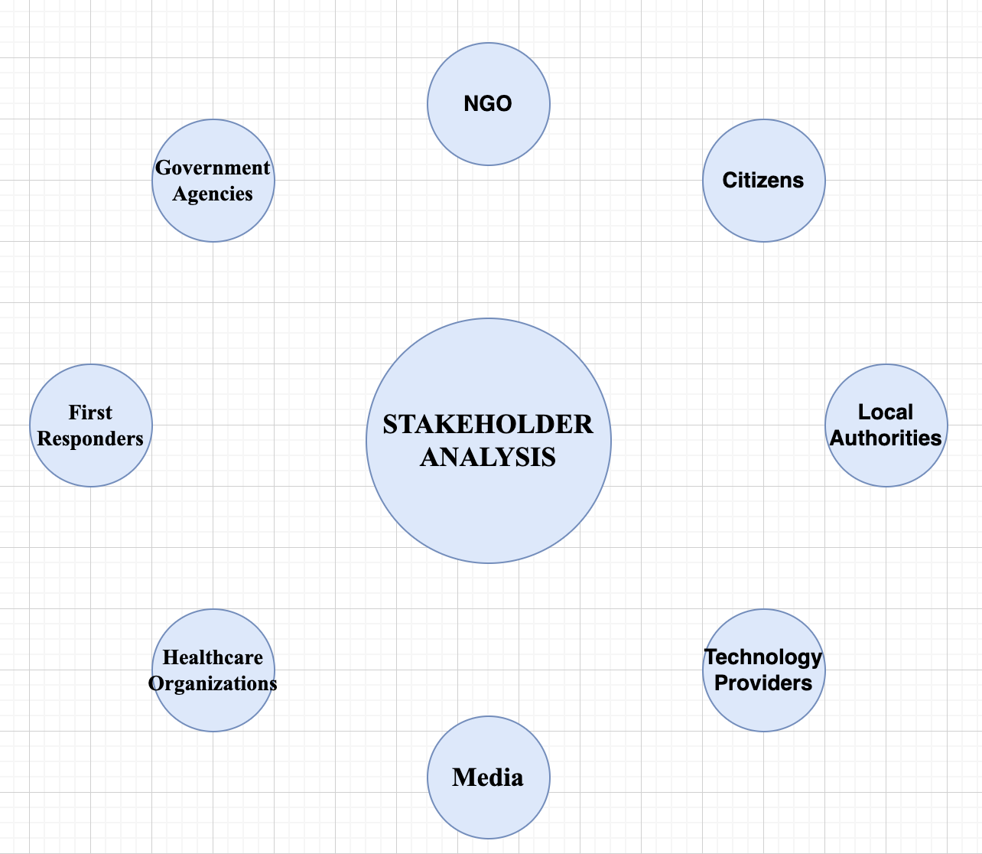

Figure 1.2 Stackholder Analysis

## RELEVANCE TO SOFTWARE SOLUTION

### Comprehensive Data Integration

Responders are given a comprehensive picture of the emergency situation by the program, which maintains and integrates many data sources. The effectiveness of responses can be improved by making well-informed decisions based on accurate and up-to-date information thanks to this integrated data management.

### Enhanced Communication

The software facilitates seamless, instantaneous communication amongst emergency responders, enabling them to synchronize their operations with efficiency. During emergencies, the instantaneous transmission of vital information facilitates faster response times and better results.

### Secure Information Storage

The program guarantees the safekeeping of crucial user information, maintaining secrecy and privacy while yet offering the data required for making emergency decisions. This protects private information from possible misuse and unwanted access.

### Alert System

The software's alert system is a crucial feature that promptly notifies impacted family members and responders about situations. This timely warning aids in the quick mobilization of aid, which may save lives and lessen the overall impact of emergencies.

### Live Situation Monitoring

The software makes it easier to track emergencies in real time, giving responders the ability to see developments as they happen. Their ability to make prompt judgments and necessary modifications is enhanced by this real-time awareness, which in turn improves their overall reactivity during times of crisis.

### Integration Of AI And Machine Learning

The program improves its capacity to assess and forecast emergencies by integrating AI and machine learning features. Responders are more equipped to foresee possible threats thanks to this proactive strategy, which also increases response efforts' efficacy.

## INITIAL THOUGHTS ON THE SCOPE OF THE EMERGENCY RESPONSE COORDINATION SYSTEM (ERCS) SOFTWARE SOLUTION

### Core Functionalities

* Real-Time Communication
* Incident Reporting and Management
* Resource Allocation
* Data Integration
* Notifications and Alerts

### Advanced Features

* AI and Machine Learning
* Live Monitoring Dashboards
* Post-Event Analysis Tools

### User Roles And Permissions

* Customizable User Roles

### Training And Support

* User Training Programs
* Ongoing Support and Maintenance

# MARKET ANALYSIS

## INTRODUCTION

The Emergency Response Coordination System aims to transform how people request assistance during emergencies by providing an efficient, dependable, and user-friendly platform for managing emergency responses. Its features and functionalities have been deliberately designed to cater to a wide range of users, ensuring that it fits the different needs of its target audience. This audience includes significant end-users in both urban and rural areas who require immediate and effective assistance during a crisis and emergency service providers who play an essential role in providing the necessary relief.

## TARGET AUDIENCE IDENTIFICATION

The Emergency Response Coordination System is a comprehensive solution designed to meet the urgent demands of individuals in emergencies and the service providers who respond to them. The system effectively supports many users by emphasizing user-friendliness, reliability, visibility, cost-effectiveness, streamlined design, and timely notifications. By providing a stable, intuitive, and accessible platform for coordinating emergency responses, the system contributes significantly to public safety and emergency service effectiveness

### Primary Target: The Public

The primary target audience consists of people of all ages living in urban and rural settings. The emergency reporting system's inclusive design and features make it an indispensable resource for anybody who requires emergency assistance.

### Secondary Target: The Emergency Service Providers

Emergency service providers are an essential element of the target audience. The system provides a more streamlined platform for receiving and managing emergency calls, allowing them to serve the community better.

### Needs Of The Target Audience

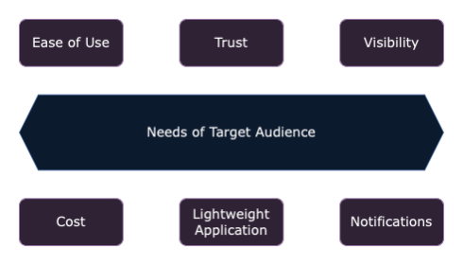

Figure 2.1 Needs of Target Audience

### Ease Of Use

The emergency reporting system's intuitive interface is fundamental to its functionality, allowing individuals to report crises quickly and easily. Recognizing that crises require fast intervention, the system is designed to cut wait times and simplify navigation. Users can conveniently enter their emergency information and be immediately routed to the necessary emergency services. This user-friendly approach is critical to ensuring that people of all ages, including the elderly and those with low technology knowledge, can effectively use the system.

### Trust

Building trust with users is critical. The system guarantees a response from emergency services, giving users confidence that their calls for assistance are not disregarded but are actively managed. Furthermore, the system can present historical data and previous encounters, increasing its dependability and the user's confidence in assisting in critical situations.

### Visibility

The emergency reporting system features a live tracking option, which is extremely useful for troubled users. This feature allows customers to track the status of their emergency reports in real-time, giving them peace of mind and reducing worry during difficult times. The ability to see when aid is on its way and track its progress can substantially improve the user's overall experience.

### Cost

Accessibility is a top priority, and the system achieves this by being free or reasonably priced. This technique assures that the service is available to anyone, regardless of financial standing, broadening the system's reach and utility. By removing financial barriers, the system ensures that people do not hesitate to use the necessary service, making emergency aid more accessible to a larger community.

### Lightweight Application

Recognizing the importance of device performance in emergency scenarios, the application is designed to be lightweight so it does not consume excessive resources on the user's device. This design decision ensures the app runs well across various devices, making it more accessible and reliable for all users.

### Notifications

The system strikes a delicate balance between keeping people informed and overwhelming them with too many warnings. Users receive enough reminders to be informed about the status of their emergency reports while avoiding superfluous or spammy alerts. This caring approach guarantees that users are well-informed while reducing the stress of the emergency scenario.

## COMPETITOR ANALYSIS

### Competition Products / Systems

* SOS messages - minimal functionality, non-user initiated.
* RapidDeploy - Cloud-based Computer-Aided Dispatch (CAD) and Emergency Response Platform.
* CentralSquare Technologies - Public Safety Suite, including CAD, Records Management, and Mobile Solutions.
* Hexagon Safety & Infrastructure - Intergraph Computer-Aided Dispatch (I/CAD) and Incident Management Solutions.
* ZOLL Medical Corporation - RescueNet Suite for EMS and Fire Services, including CAD and Mobile Solutions.
* Pulsiam  - SafetyNet CAD and Mobile Solutions for Public Safety Agencies
* Crisis Track - Incident Management and Emergency Response Software for Healthcare, Schools, and Businesses.
* ESO Solutions - Electronic Patient Care Reporting (ePCR) and Data Analytics Software for EMS Agencies.
* FirstWatch - Real-time Public Safety Data Analysis and Situational Awareness Tools for Emergency Services.
* Priority Dispatch Corporation - ProQA Suite for Emergency Medical Dispatch (EMD) and Police Dispatch.
* Spok - Enterprise Communication and Collaboration Solutions for Healthcare and Public Safety Organizations.
* V alert : No real-time notification and mass communication.
* Crash Detection on iPhone : Too many false positives Were Reported.
* Rave guardian app - limited target audience, limited functionality, private data.
* Motorola Solutions - Command Center software suite for Public Safety and Emergency Response.
* ESRI - ArcGIS Platform for Mapping, Analysis, and Real-time Visualization of Emergency Response Data.

### Competition Strengths

* Experience in different facets of emergency response, including dispatch, incident management, and data analytics.
* The emphasis is on creating user-friendly interfaces and solutions that can be customized to meet unique industry requirements.
* They have a strong, established presence in their respective areas and good client ties.
* A comprehensive suite of public safety tools, including CAD, record keeping, mobile applications, and crisis management.
* A complete set of emergency response and event management solutions.
* An extensive array of public safety systems, including hardware and software components.
* Specialization in healthcare-related emergency response solutions.
* Government agencies and organizations have widely adopted the crisis management platform.
* Industry-leading GIS (Geographic Information System) technology.
* A comprehensive critical event management platform for mass alerting and incident management.
* Focus on enterprise communication and collaboration solutions for healthcare, public safety, and other organizations.
* Experience with emergency medical dispatch (EMD) protocols and software solutions.
* Specialization in emergency notification and event management software for educational institutions, organizations, and enterprises.

### Competition Weaknesses

* + Less brand recognition than larger competitors.
  + Serving larger organizations or government bodies may present scalability challenges.
  + Some users may struggle with implementation and customization difficulties.
  + Higher startup costs than some competitors.
  + Limited coverage in non-healthcare emergency response industries.
  + Dependence on government contracts and financing, which may impact revenue stability.
  + Narrow the focus to areas of emergency response coordination other than medical dispatch.
  + Limited presence beyond the healthcare and public safety areas.

### Competition Opportunities

* Expanding into new markets, creating alliances, or entering international territories.
* Further development of mobile, cloud-based, and Internet of Things solutions.
* Enhancing software products through acquisitions, collaborations, or adding additional features.
* Developing interoperability solutions to enable seamless data interchange.
* Expanding into developing industries such as smart cities and business crisis management.
* Create specialized solutions for specific industries, use cases, or healthcare sectors.
* Expanding into new regions through innovative alliances or acquisitions.
* Introducing new features to address changing customer needs or industry trends.

### Competition Threats

* + Competition from larger, more established companies with more significant resources.
  + Technological advancements by competitors that outpace capabilities or render offerings less competitive.
  + Disruption from technological innovations that may be difficult to adapt quickly.
  + Changes in government funding or regulations affecting the emergency response industry.

## BUSINESS VALUES

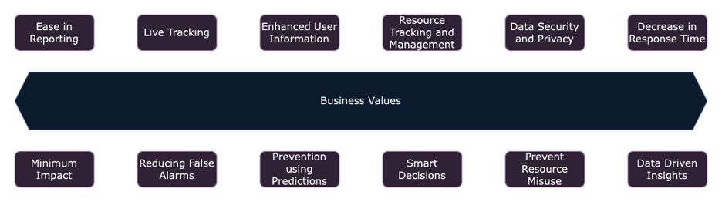

Figure 2.2 Business Values

The emergency reporting system provides numerous business benefits that significantly improve the efficiency, efficacy, and dependability of emergency response operations. This comprehensive strategy not only improves the operational skills of emergency service providers, but it also creates a safer environment for the entire community. Let's look into these company values in greater detail.

### Ease In Reporting Emergencies

#### User-Friendly Interface

The system's design prioritizes simplicity and accessibility, ensuring that users of all ages and technical abilities can report emergencies without difficulty.

#### Multi-Channel Reporting

Incorporates various reporting channels (e.g., app, web, SMS, voice) to accommodate different user preferences and situations, ensuring no barrier to reporting.

#### Multi-System Integration

Provides a singular and comprehensive view and integration of multiple public and private systems to have a single system as a point of contact. The same database is to be used as the backend for multiple views and apps for various users.

### Live Tracking For Comprehensive Visibility

#### End-To-End Tracking

Offers end-to-end tracking of the emergency response process, from initial report to resolution, ensuring accountability and transparency.

#### Stakeholder Communication

Facilitates direct communication channels between emergency responders, affected individuals, and other stakeholders for updates and coordination.

### Enhanced User Information With Mapping

#### Interactive Maps

The system provides interactive maps that display real-time information on hazards, safe zones, and rescue spots, allowing users and responders to make more educated decisions during emergencies.

#### Information Richness

It improves situational awareness by incorporating extra layers of data, such as traffic conditions and weather updates, into mapping features, resulting in a more complete picture of the emergency terrain.

### Data Security And Privacy

#### Encryption Standards

The system employs high-level encryption techniques to secure critical information exchanged within the platform, protecting data from unauthorized access.

#### Access Control

It implements strict access control procedures to ensure that only authorized staff have access to sensitive data, protecting user privacy and building trust.

### Potential Decrease In Time To Respond

#### Real-Time Data Sharing

The technology enables the immediate exchange of essential information with responders, such as the location and nature of the incident. This allows for a faster and more educated response, ensuring that support arrives when it's most needed.

### Tracking And Pre-Management Of Resources

#### Dynamic Resource Mapping

Uses GPS and GIS technology to dynamically map available resources. This enables real-time modifications based on the changing nature of situations, ensuring that resources are appropriately allocated and dispatched efficiently.

#### Predictive Deployment

The system employs trend analysis to allocate resources proactively in advance of anticipated emergencies. Forecasting potential incidents improves preparedness and greatly saves reaction times, ensuring that resources are best positioned to address emergencies effectively.

### Data-Driven Insights For Continuous Improvement

#### Performance Analytics

The system uses advanced analytics to evaluate response times, success rates, and other key performance factors, highlighting areas for improvement.

#### Root Cause Analysis (Rca)

Investigates and understands mishandled events using RCA methodology, then applies the insights learnt to enhance future emergency responses.

### Smart Decisions

#### Scenario Simulation

Models numerous emergency scenarios using historical data and predictive analytics, supporting planners and responders in making effective preparations and real-time decisions.

### Increase In Success Rate With Minimum Impact

#### Enhanced Coordination

The system increases communication and coordination among emergency services, resulting in a more coordinated response that addresses all parts of the disaster.

#### Pre-Arrival Instructions

Gives callers advice on how to handle the issue until aid arrives, potentially lowering the severity of injuries and improving overall outcomes.

### Reducing False Alarms And Unnecessary Dispatches

#### Verification Protocols

The system uses complex verification protocols to discriminate between true crises and false alarms, reducing costly and wasteful dispatches.

### Preventing The Misuse Of Resources

#### Intelligent Triage System

Implements a sophisticated triage system that prioritises emergencies based on their severity, ensuring that resources are used wisely and not squandered on non-urgent instances.

#### Feedback Loop

The system has a feedback mechanism to allow for continual improvement in resource allocation, reducing instances of resource misuse over time.

### Prevention Through Predictive Analysis

#### Risk Assessment

Conducts detailed risk assessments utilizing historical data and emerging trends to detect possible hazards and take proactive action before they become emergencies.

#### Preventative Measures

Collaborates with local authorities and communities to create preventative methods, thereby minimizing the total occurrence of emergencies.

# CONCLUSION

By addressing these essential issues, the emergency reporting system provides a comprehensive strategy to improve emergency response processes. It exhibits a thorough awareness of the complexity of emergency management and emphasizes a commitment to using technology to save lives, protect resources, and build a strong, resilient response structure.

# REFERENCES

1. An Emergency Management Plan:

<https://research.com/software/best-emergency-management-software#1>

1. Safety Culture:

<https://safetyculture.com/app/emergency-management-software/>

1. <https://www.rapiddeploy.com/>
2. <https://www.centralsquare.com/>
3. <https://www.hexagonsafetyinfrastructure.com/>
4. <https://www.zolldata.com/>
5. <https://www.pulsiam.com/>
6. <https://www.firstwatch.net/>
7. <https://www.prioritydispatch.net/>
8. <https://www.spok.com/>
9. <https://www.valcom.com/system-solutions/v-alert>
10. <https://www.ravemobilesafety.com/products/rave-guardian/>
11. <https://www.motorolasolutions.com/en_us/products/command-center-software.html>
12. <https://www.esri.com/arcgis-blog/products/insights/analytics/emergency-response-analysis-with-arcgis-insights/>